2025 Education Events Registration
____ July 24 Mt. Vernon (EVENING)
Mt. Vernon Outland Airport
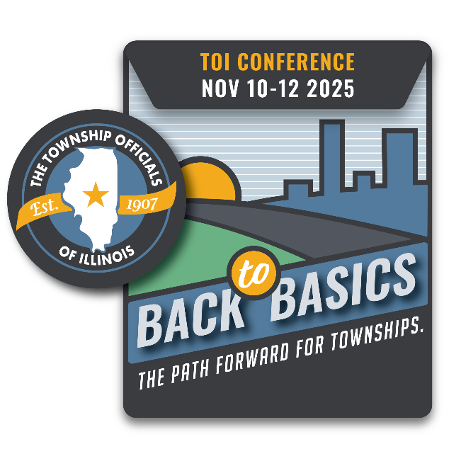
____ July 30 Mt. Sterling (EVENING)
KC Hall

September 5 East Peoria (DAY)
TBD

September 19 Rockford (DAY)
TBD

October 3 Bloomington (DAY)
TBD
County Township
Address
City State Zip
Contact person name, email, and phone number:

Names & Email of those who will attend (please print clearly):
Supervisor: Township Clerk: Highway Comm.: Assessor: Trustee: Trustee: Trustee: Trustee: Collector: Other/title:
Registration is $50 per location, per person or $400/township for up to nine attendees. On-site registration is $75 per person. No refunds will be given once TOI has confirmed attendance with venue.
*Please make checks payable to the Township Officials of Illinois; mail to 3217 Northfield Drive., Springfield, IL 62702. Forms may also be emailed to teresa@toi.org. If you are paying by credit card, only Visa and MasterCard are accepted:
Name, as it appears on card: Credit Card Number Exp.:

